Week 8 Lab

Dylan Rodwell: 105341089

# 8.1.1

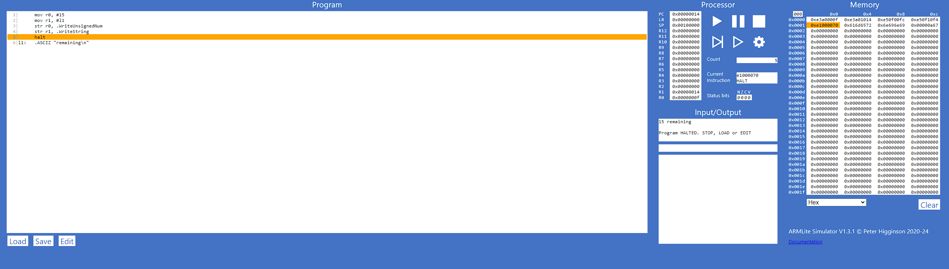

# 8.1.2

# 8.1.3

# 8.2.1

